TITLE OF THE THESIS

GRADUATE SCHOOL OF SOCIAL SCIENCES

TOBB UNIVERSITY OF ECONOMICS AND TECHNOLOGY

EKİN DENİZ YILMAZ

INTERNATIONAL RELATIONS

MASTER OF ARTS

MARCH 2022
I certify that this thesis satisfies all the requirements as a thesis for the degree of Master of Arts / Science.

______________________
Prof. Dr. Serdar SAYAN
Director of the Graduate School of Social Sciences

This is to certify that I have read this thesis and that it in my opinion is fully adequate, in scope and quality, as a thesis for the Degree of Master of Arts in the field of International Relations at the Graduate School of Social Sciences.

Thesis Advisor
Title Name SURNAME ______________________
(Name of the University, Dept.)

Thesis Committee Members
Title Name SURNAME ______________________
(Name of the University, Dept.)

Title Name SURNAME ______________________
(Name of the University, Dept.)

PLAGIARISM PAGE

I hereby declare that all information in this document has been obtained and presented in accordance with academic traditions and the rules of ethical conduct. I also declare that I have fully cited and referenced all material and results that are not original to this work, as required by these traditions and the rules of ethical conduct.

______________________

Ekin Deniz YILMAZ

ABSTRACT

TITLE OF THESIS

YILMAZ, Ekin Deniz
M.A. / M.Sc., International Relations
Supervisor: Title, Name SURNAME

In Abstract, the research question, methodology, findings and chapters are summarized. Abstract should not exceed one (1) page, be fully justified, and use 1.5 line spacing.

Keywords: It, Should, Include, Five, Words (max.)

ÖZ

TEZ BAŞLIĞI

YILMAZ, Ekin Deniz
Yüksek Lisans, Uluslararası İlişkiler
Tez Danışmanı: Unvan İsim SOYİSİM

Öz’de tezdeki araştırma sorusu, kullanılan yöntem, elde edilen sonuçlar ve bölümlerin birer cümlelik özeti yer alır. Öz’ün kendisine ayrılan bu sayfayı (toplam 1 sayfa) geçmemesi gerekmektedir. Öz, iki yana dayalı ve 1,5 satır aralıklı yazılmalıdır.

Anahtar Kelimeler: En, Fazla, Beş, Kelime, Olmalıdır

DEDICATION

Dedication in one line (center text)

ACKNOWLEDGMENTS

This page includes acknowledging persons and institutions that take part in this thesis. Should not exceed one (1) page, justified, 1,5 line spacing.

TABLE OF CONTENTS

PLAGIARISM PAGE iii
ABSTRACT iv
ÖZ v
DEDICATION vi
ACKNOWLEDGMENTS vii
TABLE OF CONTENTS viii
LIST OF TABLES ix
LIST OF FIGURES x
LIST OF ABBREVIATIONS xi
LIST OF MAPS xii
CHAPTER I 1
CHAPTER II 3
SOCIO-ECONOMIC STRUCTURE 3
2.1. Economic Strucutre 3
2.1.a. Development of the Service Sector in the Mediterranean 3
2.1.a.i. Development of the Service Sector in Italy 3
2.2. Social Structure 4
2.2.a. Demography in the Mediterranean 5
CHAPTER III 7
CHAPTER IV 9
CHAPTER V 11
BIBLIOGRAPHY 13
APPENDIX 15

LIST OF TABLES

Table 2.1. Market Profile in Italy (HKTDC 2015) 5

LIST OF FIGURES

Figure 2.1. Distribution of Male-Female Workers in the IT Sector, 2006 (Women Job Mobility 2008) 4

LIST OF ABBREVIATIONS

EU : European Union
IMF : International Monetary Fund
UN : United Nations
WWI : World War I
WWII : World War II

LIST OF MAPS

Map 2.1. Invation of Italy during the WWII (UTL 2016) 6

CHAPTER I

INTRODUCTION

Starting from Introduction, the student should print out the remainder of the thesis front and back. For this reason, including Introduction, the first pages of all chapters should be on the right sheet.
Page numbers should start from 1.
Subheadings should not be used in Introduction. It should be written with 1,5 line spacing and should be justified. In the start of each paragraph, a 0.5 cm tab space should be used.

CHAPTER II

SOCIO-ECONOMIC STRUCTURE

2.1. Economic Strucutre
…………………………………………………………………………………………………………………………………………………………..................

2.1.a. Development of the Service Sector in the Mediterranean
……………………………………………………………………………………………………………………………………………………………

2.1.a.i. Development of the Service Sector in Italy
……………………………………………………………………………………………………………………………………………………………………………………
………………………………………………………………………………………………………………………………………………………………………………………………………………………………………………………………………………………………………………………………………………………………………………………………………………………………………………………………………………………..

Figure 2.1. Distribution of Male-Female Workers in the IT Sector, 2006 (Women Job Mobility 2008)
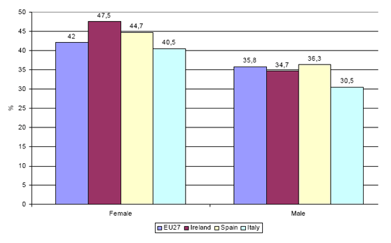
………………………………………………………………………………………………………………….

2.2. Social Structure
………………………………………………………………………………………………………………………………………………………………………………………………………………………………………………………………………………………………………………….

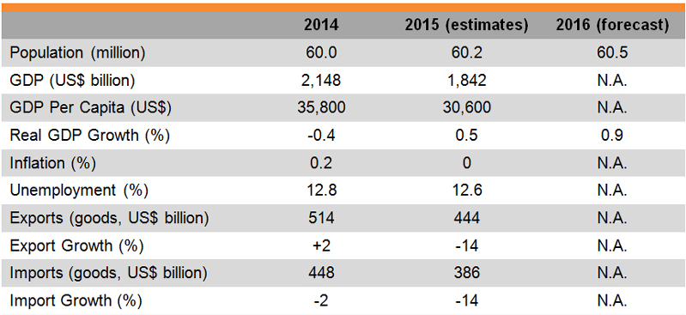
Table 2.1. Market Profile in Italy (HKTDC 2015)

………………………………………………………………………………………………………………………………………………………………………………………………..

2.2.a. Demography in the Mediterranean
……………………………………………………………………………………………………………………………………………………………………………………………………………………………………………………………………………………………………………………….
………………………………………………………………………………………………………

Map 2.1. Invation of Italy during the WWII (UTL 2016)
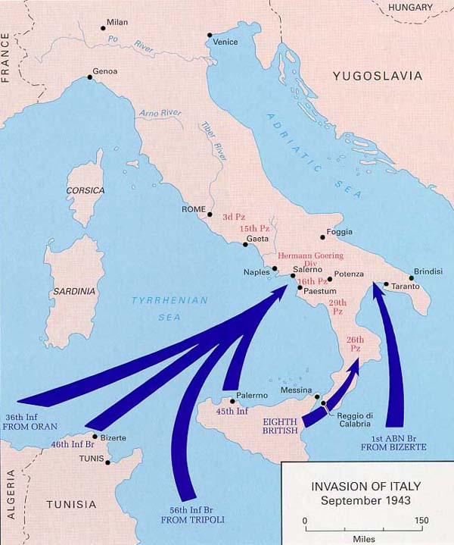

CHAPTER III

CHAPTER IV

CHAPTER V

CONCLUSION

Conclusion should refer to the obtained knowledge of the thesis and findings in a summarized fashion. There should be no subheadings in Conclussion.
………………………………………………………………………………………………………………………………………………………………………………………………………………………………………………………………………………………………………………………………………………………………………………………………….

BIBLIOGRAPHY

Bibliography should be in an alphabetic order and written in the original languages of the texts. Your references should follow the Chicago 17th edition format.

1,5 line spacing, left aligned.

APPENDIX

Footnotes should not be used for references, but only for explaining concepts and detailed additional information. For the references that are in the footnotes should be done in the same fashion of in-text citations. Footnotes should be written with 1 line spacing, Times New Roman, and left aligned.

